JAVA PROGRAMING N.NAVEENKUMAR
1.import java.util.Scanner; 192372341
public class StudentGradeCalculator {
public static void main(String[] args) {
Scanner sc = new Scanner(System.in);

try {
System.out.print("Enter total marks: ");
int totalMarks = sc.nextInt();

System.out.print("Enter number of subjects: ");
int subjects = sc.nextInt();

int average = totalMarks / subjects;
System.out.println("Average Marks: " + average);
} catch (ArithmeticException e) {
System.out.println("Error: Number of subjects cannot be zero.");
}
sc.close();
}
}
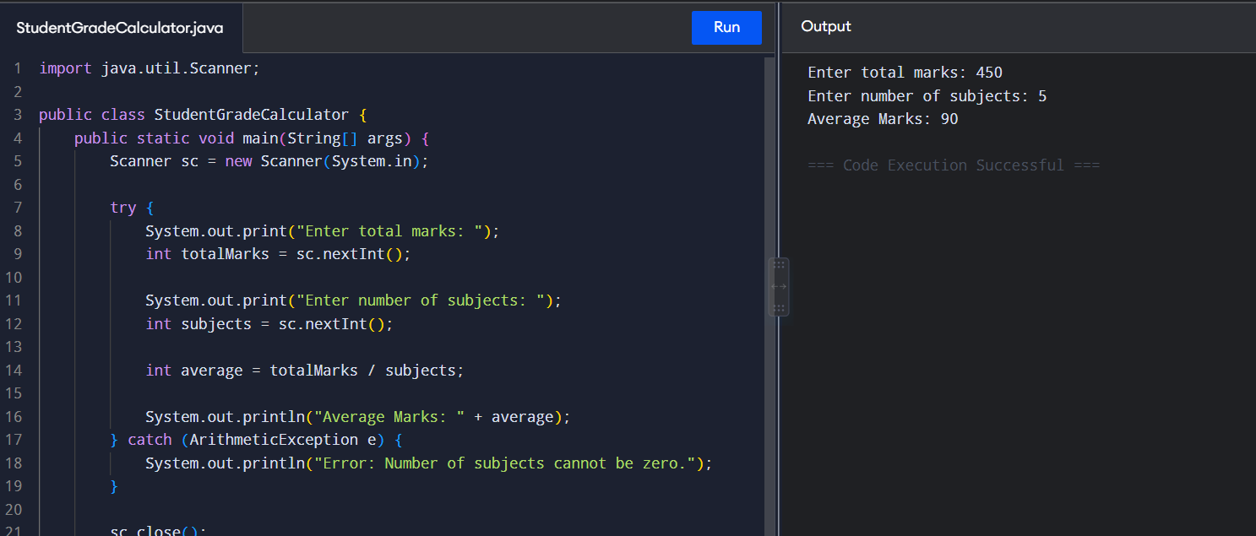

2. import java.util.Scanner;

public class BankWithdrawal {

public static void main(String[] args) {
Scanner sc = new Scanner(System.in);

System.out.print("Enter account balance: ");
double balance = sc.nextDouble();

System.out.print("Enter withdrawal amount: ");
double withdrawal = sc.nextDouble();

try {
if (withdrawal > balance) {
throw new Exception("Insufficient balance. Withdrawal cannot be completed.");
}

balance = balance - withdrawal;

System.out.println("Withdrawal successful.");
System.out.println("Updated Balance: " + balance);

} catch (Exception e) {
System.out.println("Error: " + e.getMessage());
}

sc.close();
}
}

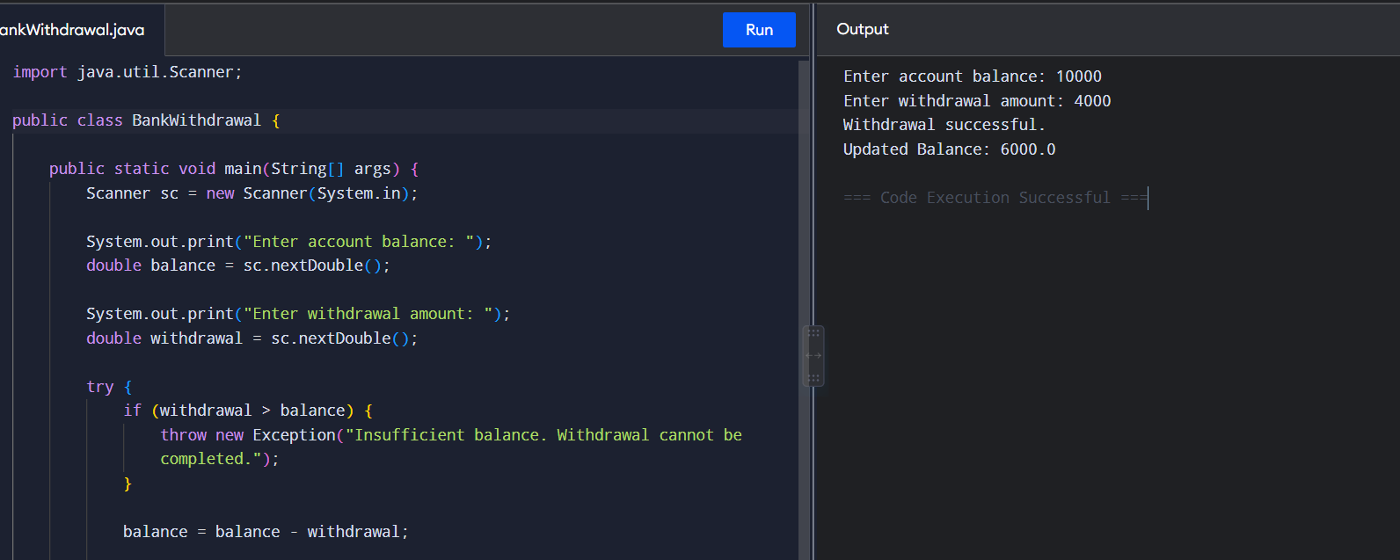

3. import java.util.Scanner;

public class InvalidAgeException {

public static void main(String[] args) {
Scanner sc = new Scanner(System.in);

System.out.print("Enter employee name: ");
String name = sc.nextLine();

System.out.print("Enter employee age: ");
int age = sc.nextInt();

try {
if (age < 18 || age > 60) {
throw new Exception("Invalid age. Age must be between 18 and 60.");
}

System.out.println("Employee Registration Successful.");
System.out.println("Employee Name: " + name);
System.out.println("Employee Age: " + age);

} catch (Exception e) {
System.out.println("Error: " + e.getMessage());
}

sc.close();
}
}

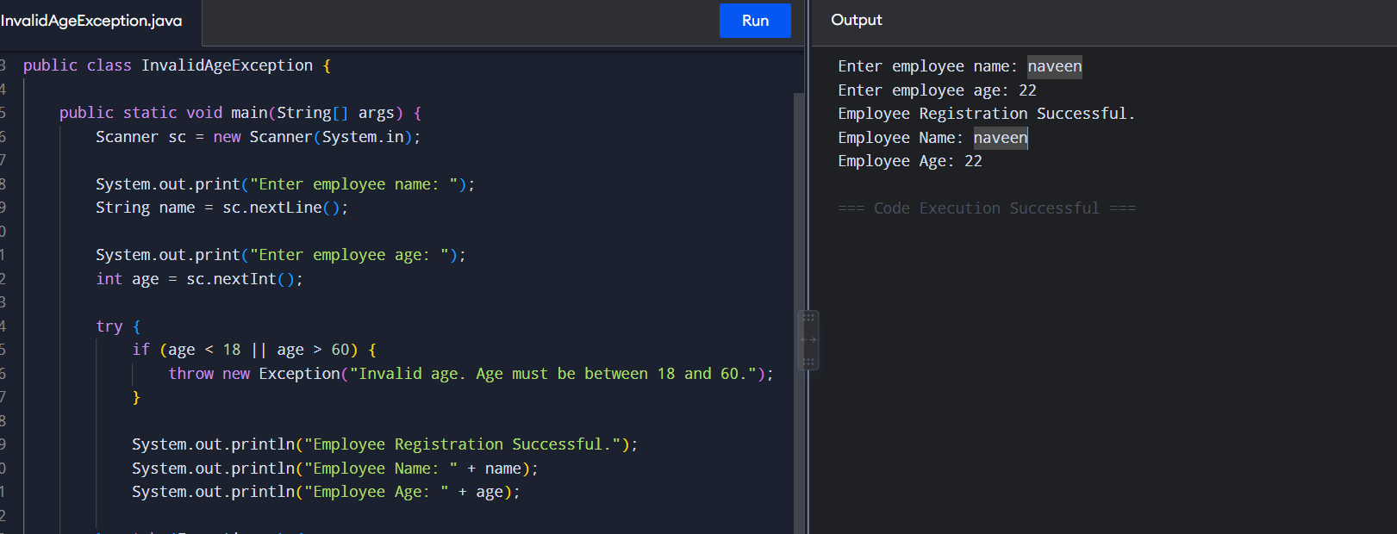

4. import java.util.Scanner;

public class StudentRecordSearch {

public static void main(String[] args) {
Scanner sc = new Scanner(System.in);

int[] marks = {85, 90, 78, 92, 88};

System.out.print("Enter student index (0-4): ");
int index = sc.nextInt();

try {
System.out.println("Student Marks: " + marks[index]);

} catch (ArrayIndexOutOfBoundsException e) {
System.out.println("Error: Invalid index.");
System.out.println("Please enter an index between 0 and 4.");
}

sc.close();
}
}

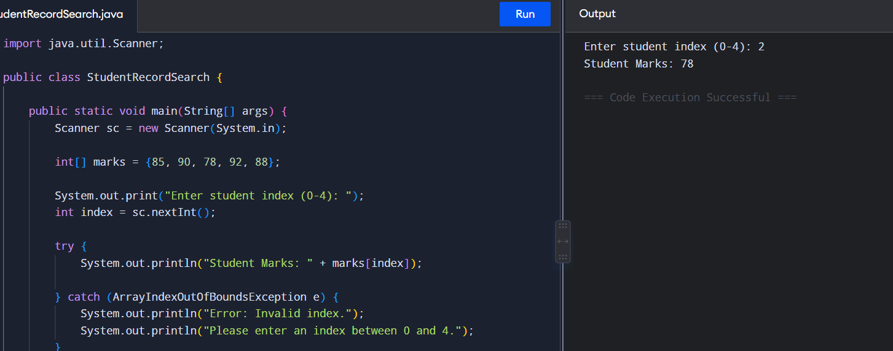

5. import java.util.Scanner;

public class ProductPriceInput {

public static void main(String[] args) {
Scanner sc = new Scanner(System.in);

System.out.print("Enter product price: ");
String price = sc.nextLine();

try {
double productPrice = Double.parseDouble(price);

System.out.println("Product Price: " + productPrice);

} catch (NumberFormatException e) {
System.out.println("Error: Invalid price.");
System.out.println("Please enter a valid numeric value.");
}

sc.close();
}
}

